
FACULTY OF ENGINEERING
DEGREE ENGINEERING
DEPARTMENT OF COMPUTER ENGINEERING
SOFTWARE ENGINEERING (BE103505)
UNIT-10 – ADVANCED TOPICS IN SOFTWARE ENGINEERING

Computer-Aided Software Engineering (CASE)
- CASE tools are software tools that help software engineers and managers in software development activities.
- They automate tasks like analysis, design, coding, testing, documentation, and project management.
- CASE tools improve software quality, reduce manual work, and increase development speed.

CASE Tools Building Blocks
- Environment Architecture: Provides the basic platform, hardware, software, database, and network support for CASE tools.
- Portability Services: Allow CASE tools to work on different hardware and operating systems.
- Integration Framework: Connects different CASE tools, allows data sharing, and provides a common working environment.

Point Solution CASE Tools
- Point solution CASE tools perform only a specific task, such as analysis or testing.
- They do not communicate with other tools or share a common database.
- Even with limited features, they can still be useful for specific software activities.
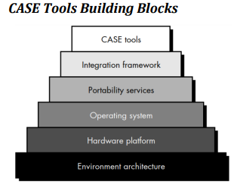

Client/Server Software Engineering
- Client/Server software engineering is the process of developing software where work is divided between:
  - Client → The user's computer or device that requests services.
  - Server → The computer that provides services and manages data.
- Different software development models can be used to create client/server systems.

Two Common Approaches:

1. Evolutionary Approach
- Software is developed in small parts.
- Each version is improved step-by-step until the final system is completed.
- It uses object-oriented and event-based programming methods.

2. Component-Based Software Engineering
- Software is built by joining already available components.
- It uses:
  - COTS components → Ready-made software components available in the market.
  - In-house components → Components created by the organization itself.

Development Steps:
Client/server software is developed using four main activities:
- Analysis → Understand what the user needs.
- Design → Create a plan for the software.
- Construction → Write the actual program.
- Testing → Check and fix errors in the software.

Software Components of Client/Server Systems
A client/server system is divided into three main parts:

1. User Interaction / Presentation Subsystem
- It is the part that users see and use.
- Example: Screens, buttons, menus, and forms.

2. Application Subsystem
- It contains the main working logic of the software.
- It performs tasks according to user requirements.
- Example: Calculating bills, processing orders, etc.

3. Database Management Subsystem
- It stores and manages data.
- It performs operations like saving, updating, deleting, and retrieving information.
- Example: Managing customer records in a database.
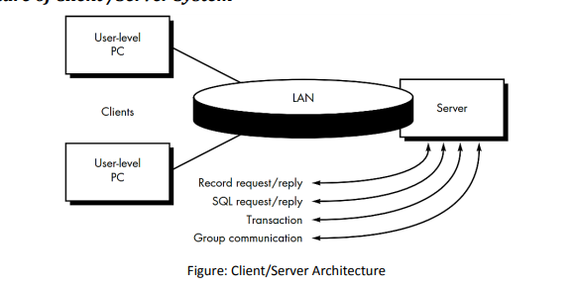

Web Engineering
- Web Engineering is the process of creating high-quality web applications (Web Apps).
- It uses many concepts and principles of software engineering, but it is specially designed for web-based systems.
- Web Engineering focuses on using proper technical methods, management techniques, and systematic processes to develop, deploy, and maintain web applications.

Web Engineering Process
- Web applications have special features that affect how they are developed.

1. Fast Development and Continuous Changes
- Web apps need frequent updates and improvements.
- Therefore, developers use an iterative and incremental process where new versions are released quickly.

2. Large and Different Types of Users
- Web applications are used by many different people.
- Developers must carefully collect user requirements and design the system according to user needs.

3. Special Web Application Design
- Web apps require proper architecture and design because they work through networks and browsers.

4. Content and Visual Design
- Web apps focus on both information (content) and appearance (design).
- Development may involve different people, such as:
  - Programmers → Develop the application.
  - Content writers → Create website content.
  - Graphic designers → Design the look and layout.

Framework for Web Engineering
- Web Engineering Framework provides a proper process model and activities to develop high-quality Web Applications.

Steps of Web Engineering Process:
- Formulation
  - Defines WebApp goals, objectives, and scope.
- Planning
  - Estimates cost, identifies risks, and prepares development schedules.
- Analysis
  - Identifies technical requirements, content needs, and design requirements.
- Engineering
  - Content Design: Creates text, images, audio, and video.
  - Page Generation: Builds web pages using development tools.
- Testing
  - Checks navigation, scripts, forms, and browser compatibility.
- Customer Evaluation
  - Customers review the WebApp and suggest changes or improvements.

